ASSIGNMENT 2

Q.1 .List the directory contents date wise sorted.(man ls)
Query: ls -lt
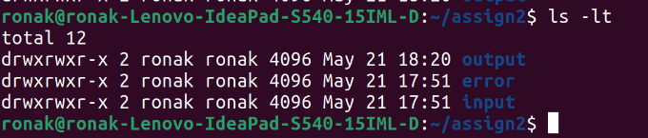
2.List the directory contents size wise sorted.(manls)
Query: ls -lS
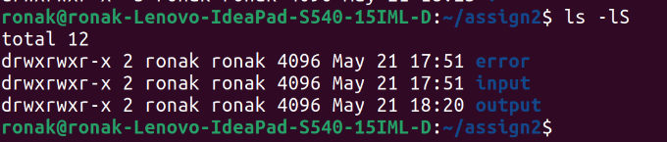
3.List directory contents along with their inode no. (manls)
Query: ls -i
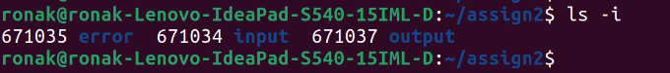
4.List the contents of the subdirectory.
Query: ls -R
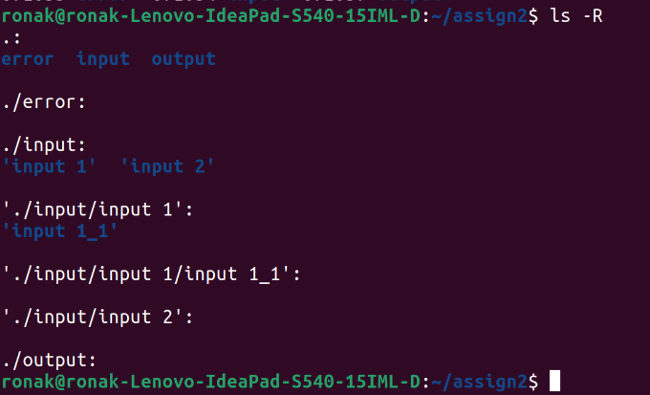
5 Create a file, write your surname and name in it and save.
i. now open the same file and add your address in it and
save.
ii. reopen the same file and check your name and address in
it.

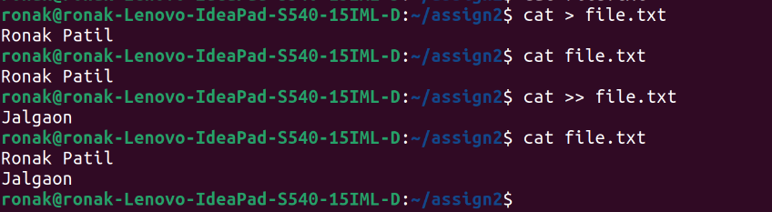
6.how to change the timestamp of file(mantouch)

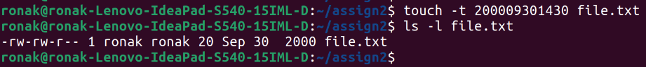
7. Create directory structure:
Give following commands,
->mkdir one
->cd one
->touch 1.txt 11.txt 111.txt
->mkdir two
->cd two
->touch 2.txt 22.txt 222.txt
->mkdir three
->cd three
->touch3.txt 33.txt 333.txt
->mkdir four\
->cd four
->touch 4.txt 44.txt 444.txt
->mkdir five
->cd five
->touch 5.txt 55.txt 555.txt
->cd~ (i.e.gotoyourhomedirectory)
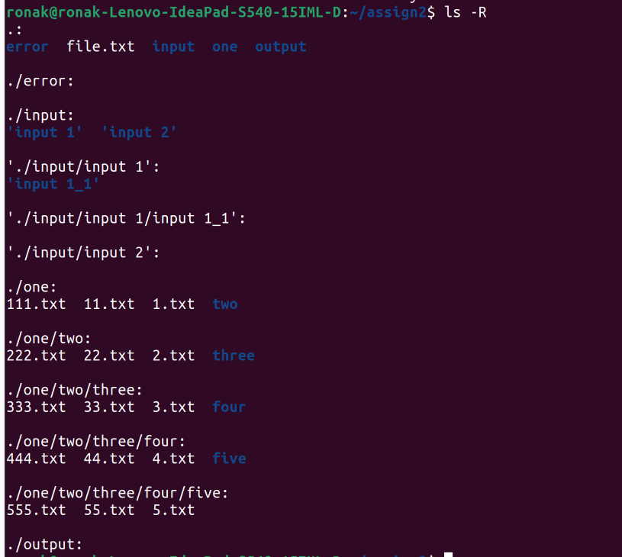

8.Considering above directory structure, Do following operations:
i. List the directory contents of directory named "five" from the current directory (i.e., home directory):
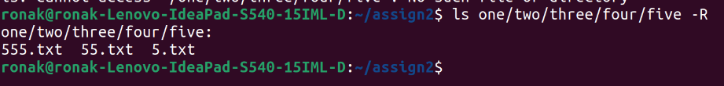

ii.write your name in a file named "44.txt" of directory "four" from current directory.
Query:
cd one/two/three/four
cat >> 44.txt
cat 44.txt
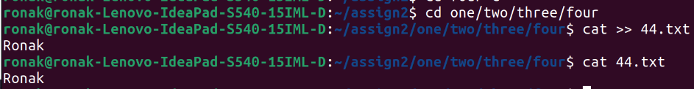

iii. remove the file named "555.txt" from directory "five" from current directory.

Query:
cd one/two/three/four/five
rm 555.txt
ls

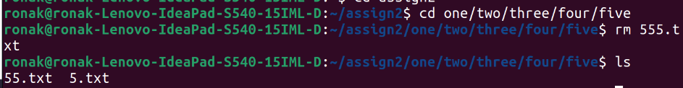

iv. change directory to five one/two/three/four/five/ ). ( i.e. cd)
v. write your course name in file named "3.txt" which resides in directory "three" from current directory (i.e. five).also read the same file.
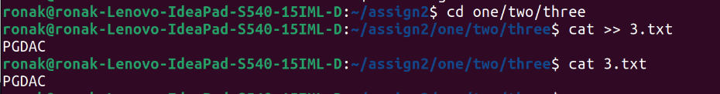

vi. list the contents of directory "two" from current directory (i.e. five).

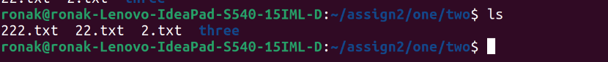
vii. remove file named "222.txt" which belongs to directory "two" from current directory (i.e. five)

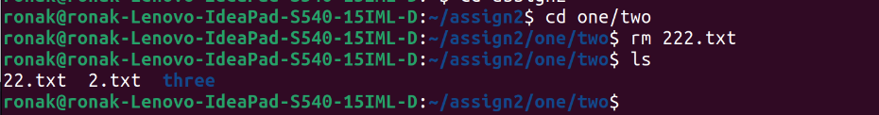
viii.now change the directory to "one"
ix.remove all files only from directory named "five" from current directory (i.e.one)

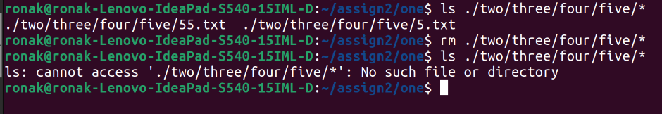

x. remove directory named "five" from current directory(i.e.one)

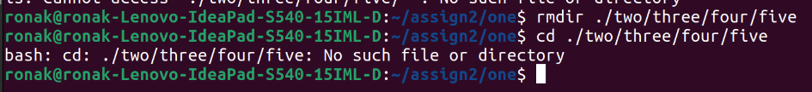

xi.remove whole directory named "four" from current directory (i.e. one)

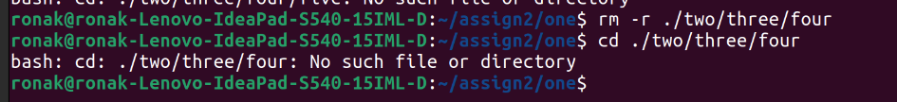

xii.change to your home directory



9. change the time stamp of file named "3.txt" which resides in directory named "three".

